RESOLUTION NO.__________

RE: CERTIFICATE OF APPROPRIATENESS UNDER THE
PROVISIONS OF THE ACT OF THE PENNSYLVANIA
LEGISLATURE 1961, JUNE 13, P.L. 282 (53
SECTION 8004) AND BETHLEHEM ORDINANCE NO.
3952 AS AMENDED.

WHEREAS, it is proposed to secure a COA for renovations to the detached garage at 1324 Prospect Avenue.

NOW, THEREFORE, BE IT RESOLVED by the Council of the City of Bethlehem that a Certificate of Appropriateness is hereby granted for the proposal.

Sponsored by: (s)

(s)

ADOPTED BY COUNCIL THIS DAY OF

(s)
President of Council

ATTEST:

(s)
City Clerk

HISTORIC CONSERVATION COMMISSION

CASE #657 -- It is proposed to remove existing asphalt singles on the roof of the detached garage and replace with new GAF Slateline asphalt shingles at 1324 Prospect Avenue.

OWNER/APPLICANT: Judy and Kenneth Loush/Kenneth Loush

The Commission upon motion by Mr. Evans and seconded by Mr. Cornish adopted the proposal that City Council issue a Certificate of Appropriateness for the proposed work as presented and described herein:

- The proposal to renovate the detached garage was presented by Ken Loush.
- Approved exterior renovations to the detached garage include removal of existing asphalt shingles and replace with GAF Slateline ‘Weathered Slate’ asphalt shingles.
- The motion for the proposed work was unanimously approved, noting Mr. Loush recused himself from HCC discussion and resulting vote.

JBL: jbl
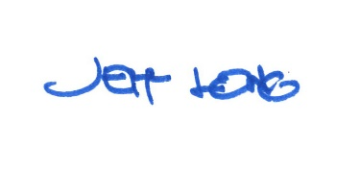

By:

Date of Meeting: July 16, 2018 Title: Historic Officer

